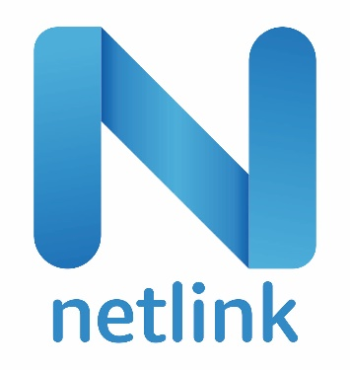

**PROPOSAL TO**



For

Implementation Multi Bid Software

Submitted by:

**Samar Qureshi**

Executive Vice President, Digital Transformation

Email: [SamarQ@netlink.com](mailto:SamarQ@netlink.com)

Mobile: +1 248 310 0095

Contents

A. Introduction and Background 3

1. Cover Letter 3

2. Executive Summary 4

3. About Netlink 4

B. Project Overview 6

1. Project Objectives 6

3. Project scope 6

4. Future Scope 7

5. Assumptions 7

C. Project Solution 7

1. Proposed execution approach 7

2. Proposed Application flow 12

3. Proposed Technology 12

4. Proposed Engagement Model 12

5. Proposed Team structure. 13

6. Proposed Work Plan 13

D. Proposed Commercials 14

1. Implementation Cost (Development) 14

2. Cloud Hosting Cost 14

3. Ongoing Support 14

1. Introduction and Background
2. Cover Letter

December 15th, 2023

**To,**

**Mr. Abdur Rahim P**

Vale Sourcing Team

**Subject:** Multi bid software for automated freight purchasing system and optimization software for “Vale Long Harbour Refinery”.

Hello Mr. Abdur,

This letter is Netlink’s formal offer to perform the services described in this proposal against the SOW shared by Vale.This proposal is firm for Ninety (90) days from the submission date.

The individual signing this letter is authorized to bind the prospective respondent contractually as described in the proposal and is the point of contact designated by Netlink.

Name : Samar Qureshi (Executive Vice President, Digital Transformation)

Email : [SamarQ@netlink.com](mailto:SamarQ@netlink.com)

Mobile : +1 248 310 0095

1. Executive Summary

We want to thank you for giving Netlink the opportunity to submit a proposal for joint development of “Multi bid software for automated freight purchasing system and optimization software for Vale Long Harbour Refinery” to enable Vale vendors to submit their freight booking requisition and finalize the freight operator.

After carefully reviewing the requirements with the Vale business team, we are confident that our product can address the current business needs. Also, with our Custom Development expertise, we designed our product to scale up easily with the ever-changing business scenarios and requirements.

Netlink believes in building a long-term partnership with our clients. It has designed its pricing proposal accordingly while offering additional investment in governance, quality assurance, and reporting platform for this strategic pilot.

1. About Netlink

Netlink has been one of the most prominent IT solution providers for approximately 25 years across the globe. As a service provider, Netlink strives to offer value-added technology and business solutions, propelling innovation, and transformation. Netlink is globally recognized for its proficient expertise and result-driven approach toward achieving peak performance.

Drawing on years of experience in delivering varied cutting-edge solutions, Netlink leverages streamlined processes, advanced systems, superior technology, and proven expertise to deliver robust IT solutions. With a commitment to excellence, Netlink continues to be a driving force in the industry, consistently delivering high-quality services to meet evolving technological needs.

We provide expert resources and support for every aspect of app development, ensuring seamless access to modern and optimized features catering to your requirements.

**Premier provider of value-added technology and business solutions.**

Netlink operates across various locations, including Michigan, the US, Dubai, three sites in India, and more, with a profound dedication to delivering high-quality technology solutions. As a leading service provider, Netlink has empowered numerous organizations effectively and continues to position itself at the forefront of fostering a data-centric culture for its clients.

**Service Verticals:**

For over 25 years, Netlink has envisioned and built the best service delivery ecosystem, providing the following services to global customers.

|  |  |  |
| --- | --- | --- |
| **Netlink Offered Services** | | |
| Digital Transformation | Infrastructure and Cloud | Document Imaging Services |
| Low-Code Services | ERP Services | Industry 4.0 |
| BI and Analytics Services | Al & Machine Learning Services | Enterprise Mobility |
| Software Factory as a Service | BPO Services | Skill Development |

1. Project Overview
2. Project Objectives

Vale's primary objective is to create a resilient platform that streamlines the freight purchasing process, aiming to enhance efficiency and facilitate a seamless bid process for freight companies. The envisioned system is designed to promote transparency and healthy competition among freight companies, ultimately ensuring Vale's access to the right-sized and cost-effective freight purchasing solution.

1. Project Overview

Netlink's proposed solution is a web-based Automated Freight Purchasing System and Optimization Software. This system is strategically designed to streamline the freight procurement process by allowing owing freight companies to bid for shipping orders posted by the Vale vendors. Moreover, the system is versatile, offering two potential enhancements in future customization phases: -

* Integration with SAP Solutions: The system has the potential to seamlessly integrate with other SAP solutions, enhancing overall business processes and ensuring compatibility within the existing infrastructure.
* Automated Billing Functions: Another potential enhancement involves integrating the system with automated billing functions, providing a more streamlined and efficient financial process.

1. Project scope

Netlink will undertake the following scope of work based on Vale's requirements for the web-based Automated Freight Purchasing System and Optimization Software:

* Design and develop an intuitive web interface for the seamless posting of shipping orders and efficient bid management.
* Implement an advanced automated bidding system that empowers freight companies to submit competitive bids with ease.
* Ensure robust security measures to safeguard sensitive freight and business information, prioritizing data protection and confidentiality.
* Integrate comprehensive reporting and analytics features, providing valuable insights for performance evaluation and informed decision-making.

1. Future Scope

Netlink's future scope of work for the web-based Automated Freight Purchasing System and Optimization Software also includes:

* Seamlessly integrate with SAP system to facilitate streamlined data exchange and synchronization, ensuring cohesive and efficient business processes.
* Implement integration with automated billing functions to enhance financial processes and contribute to overall operational efficiency.

1. Assumptions

Netlink would like to anticipate the following assumptions for the project:

* Stable Internet – Netlink assumes users have reliable internet for system access.
* Training Support – Netlink assumes adequate training is provided for a smooth transition.

1. Project Solution
2. Proposed execution approach

Netlink Agile methodologies aim to deliver the right product, with incremental and frequent delivery of small chunks of functionality, through small cross-functional self-organizing teams, enabling regular customer feedback and course correction as needed. Netlink Agile methods also include technical practices, that enable Test Automation, Continuous Integration/ Continuous Delivery/ Deployment (CI/ CD) and overall, an ever-shrinking delivery cycle for software and other products and services. Netlink Agile methodologies are product development approaches that are aligned with the values and principles described in the Agile Manifesto for software development.

Scrum methodology is a simple framework for working with complex projects. Agile software development methodologies are iterative, meaning the work is divided into iterations, which are called Sprints in the case of Scrum. Scrum is executed by small teams of 5-7 people, including a Scrum Master and a Product Owner. In Scrum, projects are divided into cycles (typically 2- or 3-week cycles) called Sprints. The Sprint represents a timebox within which a set of features must be developed.  Multiple sprints might be combined to form a Release – where formal software/ product delivery is made to the customer/ market.

* The Product Owner breaks down the overall product functionality into smaller features (typically described as Epics and User Stories – or just Stories).   These Stories are prioritized and taken up in each Sprint or Iteration.  The intent of the method is for the team to be able to demo at the end of each Sprint working pieces of the product to the Product Owner to make sure that the product is working as intended. ​
* Overall, the Scrum method breaks the long waterfall process delivery into smaller cycles, which enables product teams and the end-customer to frequently review working software and ensure that it meets their business requirements. This ensures that the product also meets the final requirements of the customer. ​
* The Scrum method is characterized by specific ceremonies such as the Daily Stand-up meeting, the Sprint Review Meeting, the Demo to the Product Owner and the Sprint Retrospective meeting.  All these meetings provide collaboration and review opportunities to the team to ensure that development is progressing as intended and any issues are resolved quickly. ​

**EXECUTION METHODOLOGY - SPRINT EXECUTION WORKFLOW**

Netlink will follow the below workflow for executing the development sprints in cadence.

**Product Backlog**

In the initial steps, Netlink will list the work that needs to be done and deliverables in phase 1, phase 2 and phase 3. With the help of the Business Analyst team, Netlink shall refine the user stories and prioritize the user stories based on the nature of the application and successful completion.

**Epic**

Netlink approaches the function of ‘epic’ as an identification of a large body of work that can be broken down into several smaller stories, sometimes called “Issues” in Jira. Epics often encompass multiple teams on multiple projects and can be tracked on multiple boards. Epics are always delivered over a set of sprints.

**Story**

Netlink approaches the story in Jira to be represented as an issue of type Story. It tells a story about a customer or user employing the product. It comprises a name, a brief narrative, acceptance criteria, and conditions to be met for completion.

**Spike**

Netlink identifies spike as a user story for which the team cannot estimate the effort needed. In such cases, opting for a time-boxed research and exploration approach is advisable to gain insights into the challenges or potential solutions. Following the spike, the team can then break down the features into more manageable stories and provide accurate effort estimates.

**Task**

Netlink’s approach with Jira tasks is part of a Story and function as single to-dos that one person generally completes in a day or less. Whereas a Story will express a goal or result, a Task is a responsibility or step in the process. Stories may encompass multiple tasks that need to be completed simultaneously.

**2-4 Weeks Sprint Execution:**

Netlink’s methodology includes dividing each sprint into 2-4 weeks and wherein its directed to follow the below-mentioned activities to deliver the project successfully via implementing Agile methodology.

**Sprint Planning:**

Netlink’s approach to sprint planning aims to define what can be delivered in the sprint and how that work will be achieved. Sprint planning is done in collaboration with the whole scrum team. Stories for the next sprint will be finalized in this meeting and to be added in the future sprints based on priority.

**Development /Defect Fixing:**

This stage will follow Agile Methodology of iterative and incremental development; thus, the requirement and solutions will evolve through collaboration with the client and Netlink team, which will help us to encourage the team to:

* + Have rapid and flexible changes in the development environment,
  + And resolve the defect as per the client’s inputs.

**Daily Scrum:**

The primary goal of the daily stand-up is to discuss progress and identify blockers.

**Bug Triage:**

The primary goal for this session is to discuss bugs in weekly bug triage meetings.

**Backlog Grooming:**

The primary goal of backlog grooming is to keep the backlog up-to-date and ensure that backlog items are prepared for upcoming sprints. This session would be conducted frequently to gather all the backlog items for a discussion, review, and prioritization for product managers, product owners, and the rest of the team.

**Sprint Demo**

The primary aim to conduct Sprint Review (Demo) is to allow the Scrum Team to showcase their accomplishments during the sprint. It concurrently provides a valuable opportunity for key stakeholders to inspect the increment and make necessary adaptations to the Product Backlog.

**Sprint Retrospective**

After the sprint demo/review, the Netlink team will do a sprint retrospective before the kick-off of the next sprint. This helps the team to identify the following:

* Successes of the Previous Sprint
* Challenges of the Previous Sprint
* Optimization Strategies for Team Efficiency

**Weekly Status Meeting**

The primary goal is to discuss the progress of the project, a weekly status meeting with stakeholders to summarize the progress.

**Code review-**

In this session the primary goal is to conduct Code review, and it will be done by Peers /Technical Lead and suggested feedback to improve code will be implemented.

**UAT**

The primary goal of a UAT session is to test earlier sprint user stories and current sprint.

1. Proposed Application flow

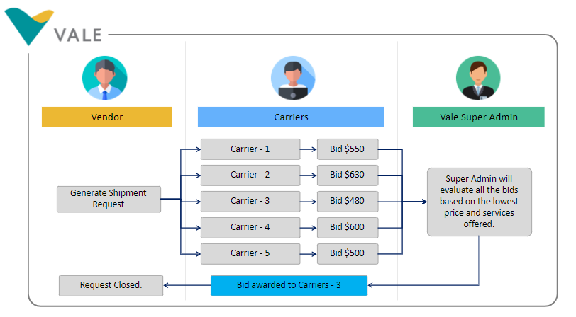

1. Proposed Technology

Netlink proposed the below technology to develop the application:

|  |  |
| --- | --- |
| **Technology** | ASP.NET |
| **Database** | MySQL |
| **Design** | Bootstrap |

1. Proposed Engagement Model

Netlink will provide customization & implementation services utilizing its Software Factory as a Service (“SFaaS”) engagement model, as described below, to deliver this scope mentioned in the above section:

* Client may purchase Software Factory Units (“SFUs”).
* Each SFU is equivalent to a full-time equivalent resource (“FTE”) incorporating various skilled IT resources that address all phases of software development from inception to transition to maintenance and support.
* Netlink shall allocate skills and roles within an SFU as needed, based on the project needs.
* 1 SFU is equivalent to 160 hours of utilization in a month.
* SFaaS resources will be based remotely.
* All personnel resources providing Services will be Netlink employees.

The below flow chart explains the complete process of SFaaS:

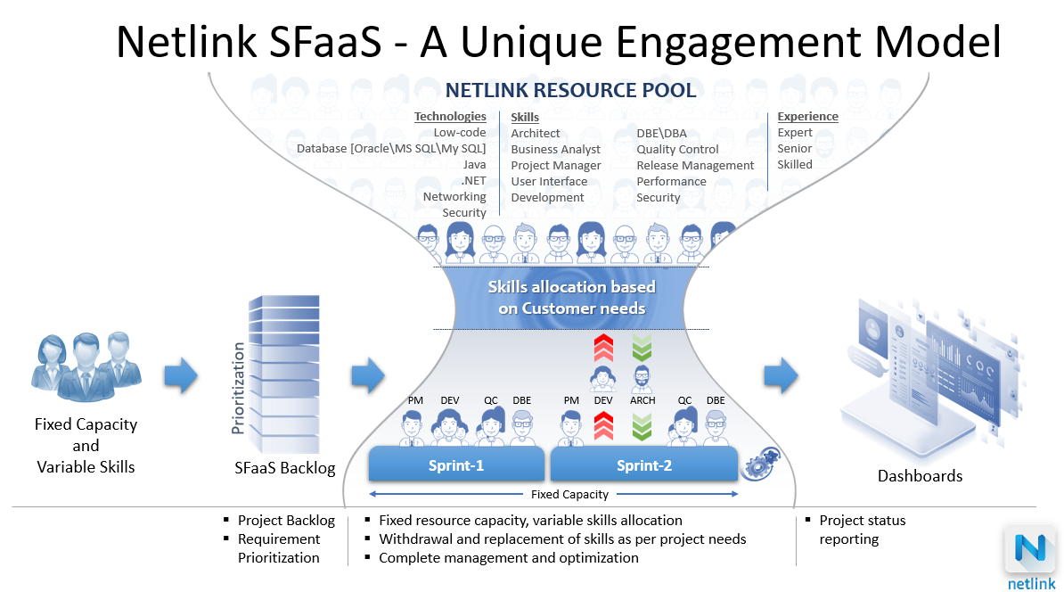

The team needed for the execution of the project is mentioned in the next section-5 (Proposed Team)

1. Proposed Team structure.

The role constitution for the Software Factory Unit (SFU) is mentioned below:

|  |  |  |
| --- | --- | --- |
| **Role** | | |
| Project Manager | .Net Developer | UI/UX Designer |
| Business Analyst | Database Developer | Quality Engineer |

1. Proposed Work Plan

Netlink proposed the below-mentioned work plan regards to the requirement we received from Vale



1. Proposed Commercials
2. Implementation Cost (Development)

|  |  |
| --- | --- |
|  |  |

1. Cloud Hosting Cost

|  |  |
| --- | --- |
|  |  |

1. Ongoing Support

|  |  |
| --- | --- |
|  |  |